Simply order with
your smartphone!
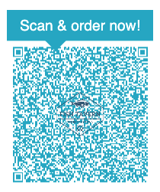
☑ Scan the QR code with
your smartphone camera .
___________________________________
☑ After placing your order please
indicate table number ____________.
___________________________________
☑ Enjoy your meal!

